Use-Case Realization Report (Requirements)
Give Change

Issue 3.0
Revision History
Date | Issue | Description | Author
13 July 2000 | 1.0 | First Issue | Howard Russon
20 July 2001 | 2.0 | Revised for MTech Unit 3 in 2001 | Howard Russon
22 July 2004 | 3.0 | Revised for MTech Unit 3 in 2004 | Howard Russon

Table of Contents
1. Brief Description 4
2. Flow of Events 4
2.1 Standard Flow 4
2.2 Exceptions 4
3. Interaction Diagrams 5
3.1 Domain Collaboration Diagram: Give Change 5
4. Participating Objects 5
5. Class Diagrams 6
5.1 Domain Class Diagram: Give Change 6
6. Derived Requirements 6

Use-Case Realization Report
Give Change

Brief Description
This abstract use case enables change to be issued to the Customer.

Flow of Events
The standard flow of events for this use case and any exceptions are described in the following subsections. See section 3.1 for an overview of the participating Actors and Domain Objects.

Standard Flow
This use case is used by use case Coin Input and Select Brand to issue any required change as follows:
- After the selected drinks brand has been dispensed, the vending machine will next issue any change that is required to the Customer.
- The price of the selected Drinks Brand and the total money entered by the Customer will then be compared, and hence the amount of change required will be calculated
- Coins, totaling the required sum, will then be selected from the denominations held by the machine. In the real vending machine, these Coins will then be sent to a cash tray built into the Customer Panel. In the computer simulation, the value of the Coins will appear in a panel next to the caption “Collect Coins” on the Customer Panel.
- If less than the required amount change could be given, then the caption ”No Change Available” will be highlighted on the Customer Panel.
- To reflect the Coins that have been issued as change, the internal records of the number of Coins of each denomination held by the machine will be appropriately deceased.
- If as a result of issuing the change, it is deemed that there is no longer enough cash available in the machine to issue change for subsequent transactions, then the caption ”No Change Available” will be highlighted on the Customer Panel.
- Finally, the Machinery Simulator Panel will be updated to show the new totals for Coins of each denomination held by the machine.

Exceptions
The following exceptions have been identified:
- Fault is Detected. If the sensors detect a fault while issuing the change (resulting in no change being issued) then a fault message is returned.
- Not Enough Change Available. If less than the required amount of change is available, then what change can be given will be issued to the Customer. In addition, a sign saying ”No Change Available” will be displayed on the Customer Panel.

Interaction Diagrams

Domain Collaboration Diagram: Give Change
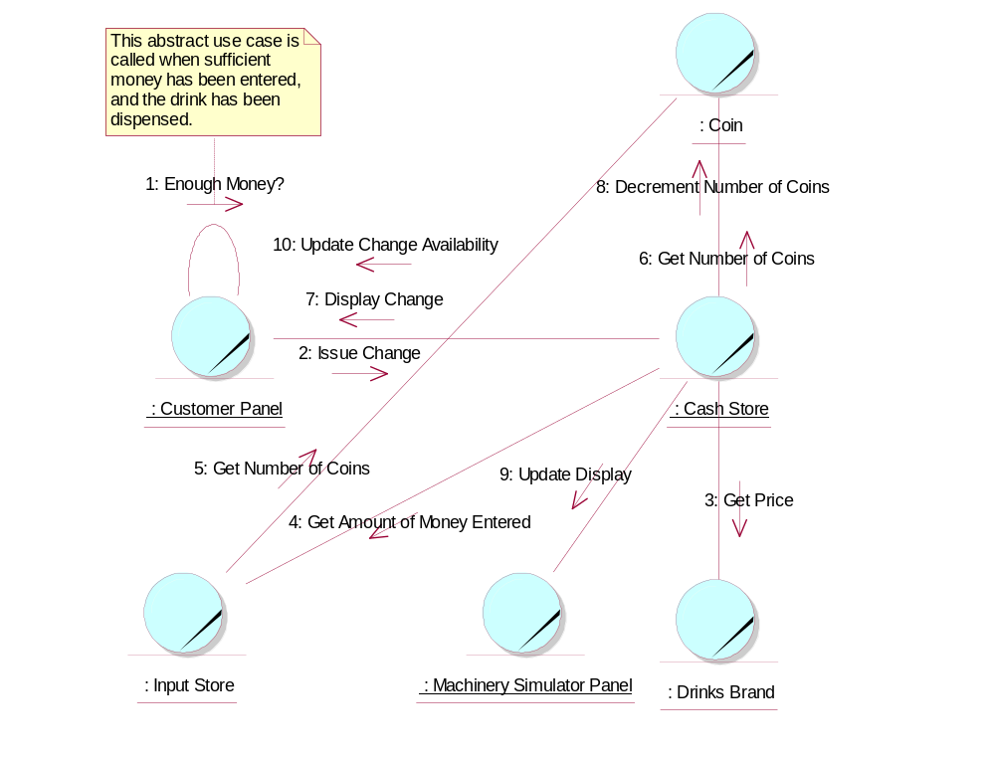

Participating Objects
: Cash Store
This is the repository for all Coins entered into the system. It is also where all change given to the Customer is taken from.
: Coin
The object stores the characteristics of coins entered into the system.
: Customer Panel
This panel simulates the vending machine's customer interface panel. It will enable the user (the Customer) to:
1 insert coins;
2 select brands;
3 terminate transaction.
It will also provide the following display functions:
1 display total money inserted;
2 indicate coin not valid;
3 indicate no change available;
4 display the value of the change to be collected;
5 display an icon representing the dispensed drink.
: Drinks Brand
This object stores the characteristics of the types of drinks can held in the system.
: Input Store
When Coins are entered into the Customer Panel, they are initially held in this store until the correct amount of money has been entetred by the Customer.
: Machinery Simulator Panel
This panel simulates the physical actions of the maintainer. It enables the user to:
1 display and enter new values for the number of cans of each Drinks Brand held by the Drinks Store;
2 display and enter new values for the number of Coins of each denomination held by the Cash Store;
3 display whether the vending machine Door is unlocked, and enable it to be locked.

Class Diagrams

Domain Class Diagram: Give Change
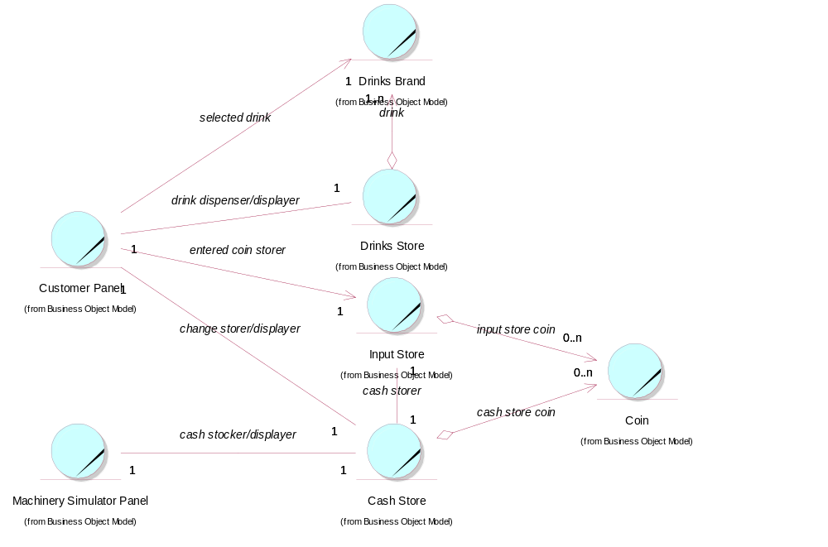

Derived Requirements
In the real vending machine, a cash try is required to be built into the Customer Panel.

